Use Case - Document

Module Name:Approve agent

Use Case Name: Verification of agent

# ID:102

# Name:Verification of agent

# Title:

Agent verification.

# Description:

Admin will fetch the details about agents from the database of system and then admin will verify all the details about agents. If details are correct then admin will send the approval message to the system.

# Use Case Diagram:

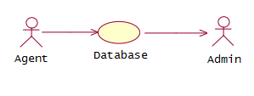

# Pre-Conditions:

1. Admin should be logged in the system.
2. Details of agent should be present in the database.

# Post-Conditions:

1. If details are correct then admin will send the approval message to system.

# Primary Flow:

1. Admin will log in into the system
2. Admin will fetch the details about agents.
3. Admin will check the details about agents.
4. If details are correct then admin will send the approval to the system.

# Alternate Flow:

1. Details are not correct
   * If details of agent are not correct then system will send the disapproval message to the system.

# Exception Flow:

1. Details of agents are not present
   * If details of agents are not present then admin will wait for specific time and then after some time it will check for the details again.

# Data:

1. Agent login credentials
2. Agent details